# Project Design Phase-I Solution Architecture

|  |  |
| --- | --- |
| Date | 30 OCTOBER 2022 |
| Team ID | PNT2022TMID21389 |
| Project Name | Gas Leakage Monitoring System |
| Maximum Marks | 4 Marks |

**PROBLEM STATEMENT:**

In most industries, one of the key parts of any safety plan for reducing risks to personnel and plant is the use of early-warning devices such as gas detectors. These can help to provide more time in which to take remedial or protective action. They can also be used as part of a total, integrated monitoring and safety system for an industrial plant. Rapid expansion of oil and gas industry leads to gas leakage incidents which are very serious and dangerous. Solutions need to be found out at least to minimize the effects of these incidents since gas leaks also produce a significant financial loss. The challenges are not only to design a prototype of the device that can only detect but also automatically respond to it whenever the leakage occurs.



**Solution Architecture:**

**Components:**

**Hardware part**

* Gas Sensor

**Software part:**

* Python IDLE
* Node RED

# Example - Solution Architecture Diagram:

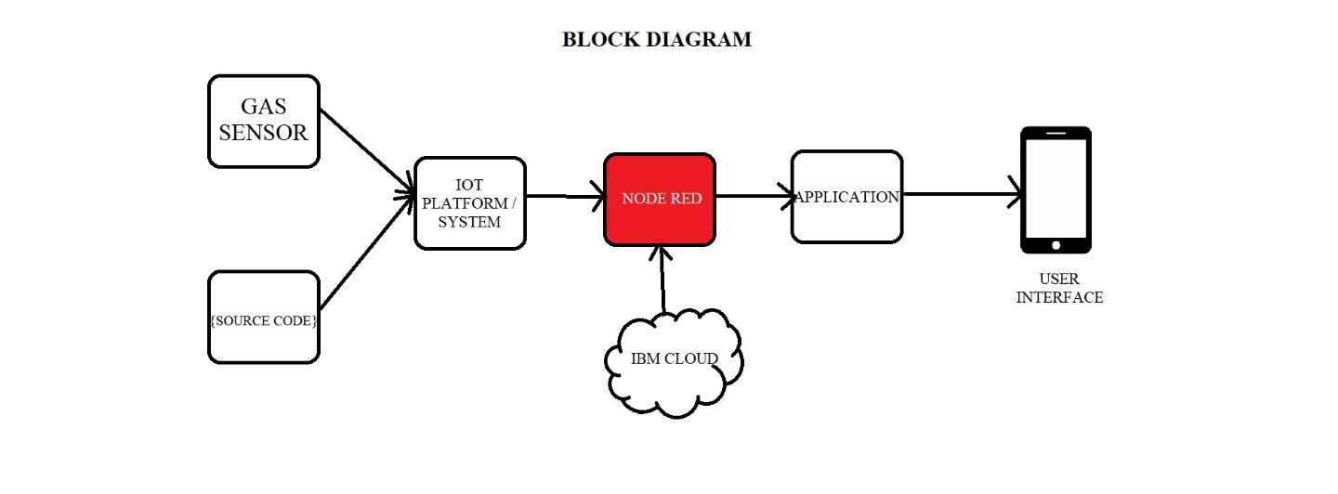

This gas leak detector system contains two features, this includes the SMS Gateway feature for only sending warning information regarding the gas leak to user, and the Alarm for the warning alert. There is some improvement which can be applied for the future work, such as regarding the SMS Gateway, it need to enhance with feature such as notifying the user whenever the remaining credit balance is insufficient. Another thing which can be enhanced is regarding the sensor, the sensors in this module do not include somewhat notification for notifying the user whenever the sensor not working properly or not connected to the microcontroller for some cases, therefore, it is recommended to add this kind of features in the future work for better refinement.